Date : 20th July 2026

Practical – 1
Aim : Make a Registration Form using HTML
Source code : form.html
<!DOCTYPE html>
<html lang="en">
<head>
<meta charset="UTF-8">
<meta name="viewport" content="width=device-width, initial-scale=1.0">
<title>Registration Page</title>
<link rel="stylesheet" href="styles.css"/>
</head>
<body>
<h1 style="text-align:center">Registration Form</h1>
<div class="container">
<div class="imagestyle">
<img src="img1.png" alt="Image"/>
</div>
<form class="formstyle">
<label>
Name : <input type="text" id="name" placeholder="Enter Name"/>
</label><br><br>
<label>
Email : <input type="email" id="email" placeholder="Enter Email"/>
</label><br><br>
<label>
Password : <input type="password" id="password" placeholder="Enter
Password"/>
</label><br><br>
<fieldset>
<legend>Choose Gender</legend>
<input type="radio" name="gender" value="Male">Male
<input type="radio" name="gender" value="Female">Female
<input type="radio" name="gender" value="Other">Other
</fieldset><br><br>
<fieldset>
<legend>Choose Hobby</legend>
<input type="checkbox" name="hobby" value="Male">Chess
<input type="checkbox" name="hobby" value="Female">Hockey
<input type="checkbox" name="hobby" value="Other">Football
</fieldset><br><br>
<label>
Course : <select name="course" id="course">
<option value="BE">BE</option>
<option value="BCA">BCA</option>
<option value="other">Other</option>
</select>
</label><br><br>
<button type="submit">Submit</button><br><br>
</form>
</div>
</body>
</html>

styles.css

.container{ display:flex; flex-direction: row; justify-content:center; align-items:center; background-color:beige; width:80vw; position:absolute; right:110px; }
.imagestyle{ padding:40px;
}

img{
height:60vh; width : 40vw; }
}

Output :
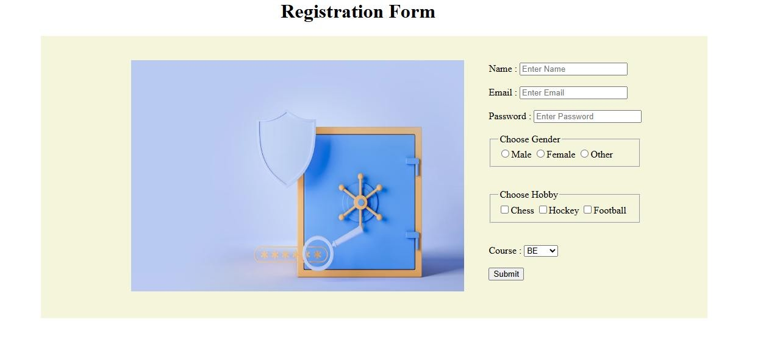

Logical Application
- What is the difference between using CSS media queries for responsiveness versus using a framework like Bootstrap's grid system?

- What is a "breakpoint" in responsive web design, and why were 768px and 480px chosen in this form?

Date : 20th July 2026

Practical – 2
Aim : Make a Registration Form Responsive using media queries x
@media (max-width : 899px){
.imagestyle{ display:none;
}
.formstyle{ padding:20px;
}
}

@media (max-width:659px){
.container{ right:50px;
}
Output :
At 918 x 546 px :
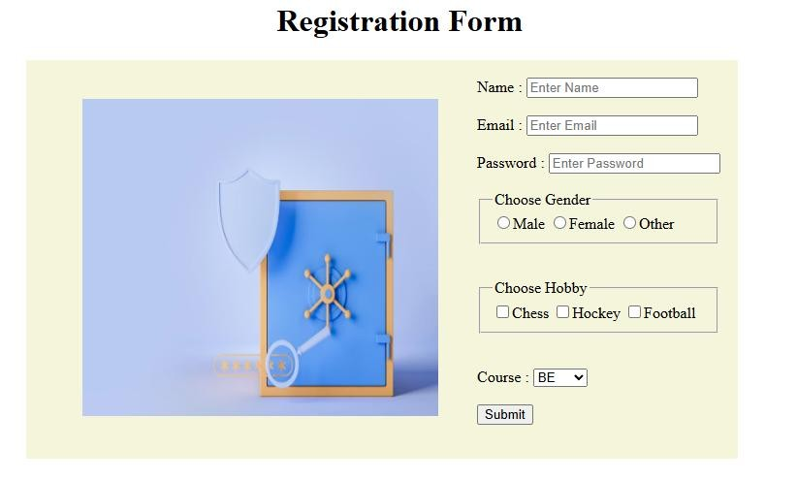

At 640 x 546 px :
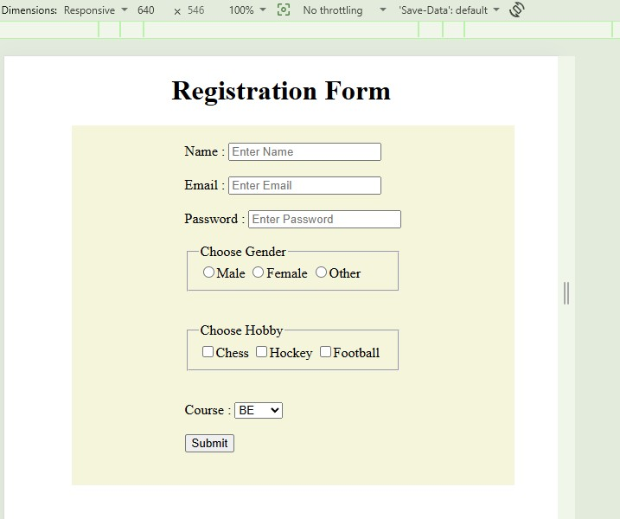

Logical Applications

- Why does the .form-row change from flex-direction: row to column inside the media query — what problem would occur if it stayed as a row on a small screen?

- Why is the max-width unit used in media queries instead of min-width in this form, and what would change if you used min-width instead?

Date : 20th July 2026

Practical – 3
Aim : Make a Responsive Registration Form using Bootstrap 5.

Source code :
bootstrapform.html
<!doctype html>
<html lang="en">
<head>
<meta charset="utf-8">
<meta name="viewport" content="width=device-width, initial-scale=1">
<title>Bootstrap demo</title>
<link href="https://cdn.jsdelivr.net/npm/bootstrap@5.3.8/dist/css/bootstrap.min.css" rel="stylesheet" integrity="sha384-
sRIl4kxILFvY47J16cr9ZwB07vP4J8+LH7qKQnuqkuIAvNWLzeN8tE5YBujZqJLB" crossorigin="anonymous">
</head>
<body class="bg-white d-flex justify-content-center align-items-center vh-100">
<div class="container-md text-center">
<h1 class="mb-5">Registration Page</h1>
<div class="row bg-primary-subtle shadow-lg">
<div class="col-md-5">
<img src="img1.jpg" class="img-fluid rounded m-5"/>
</div>
<div class="col-md-7 mt-3 p-5">
<div class="input-group mb-3">
<input type="text" class="form-control" placeholder="Username" arialabel="Username">
</div>

<div class="input-group mb-3">
<input type="text" class="form-control" placeholder="Email" arialabel="Recipient’s username" aria-describedby="basic-addon2">
<span class="input-group-text" id="basic-addon2">@gmail.com</span>
</div>
<div class="input-group mb-3">
<span class="input-group-text">Address</span>
<textarea class="form-control" aria-label="With textarea"></textarea> </div>
<div class="input-group mb-3">
<input type="password" class="form-control" placeholder="Password" arialabel="password" aria-describedby="basic-addon2">
</div>
<button type="submit" class="btn btn-primary m-3">Submit</button>
<button type="submit" class="btn btn-danger">Reset</button>
</div>
</div>
</div>
<script src="https://cdn.jsdelivr.net/npm/bootstrap@5.3.8/dist/js/bootstrap.bundle.min.js" integrity="sha384-
FKyoEForCGlyvwx9Hj09JcYn3nv7wiPVlz7YYwJrWVcXK/BmnVDxM+D2scQbITxI" crossorigin="anonymous"></script>
</body>
</html>

OUTPUT :
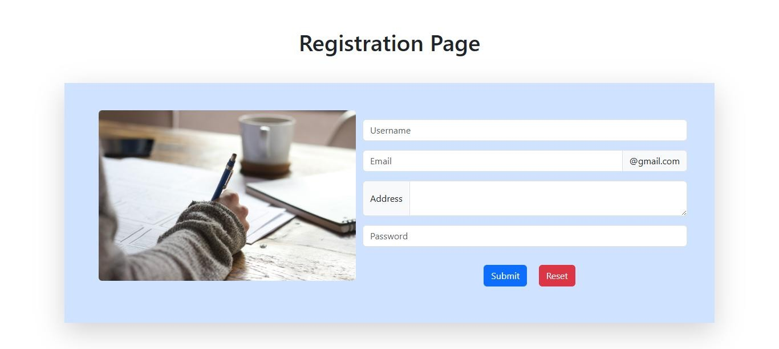

(3.2) :To make this exact responsive design using Bootstrap 5

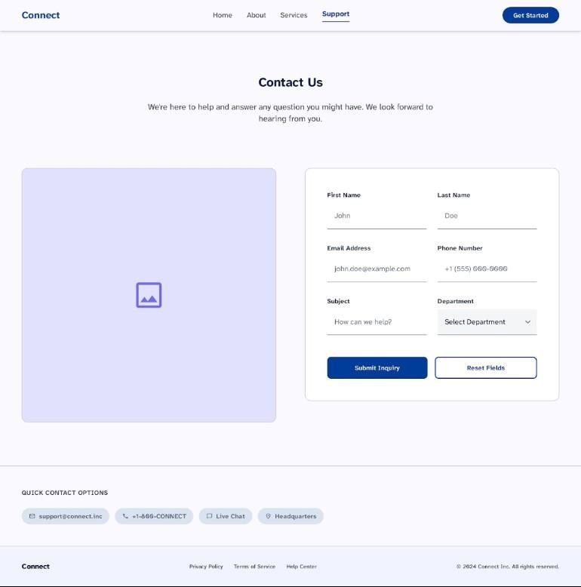

Source Code :
<!DOCTYPE html>
<html lang="en">
<head>
<!-- Required meta tags -->
<meta charset="utf-8">
<meta name="viewport" content="width=device-width, initial-scale=1">

<link rel="stylesheet" href="style3.css"/>
<!-- Bootstrap CSS -->
<link href="https://cdn.jsdelivr.net/npm/bootstrap@5.0.2/dist/css/bootstrap.min.css" rel="stylesheet" integrity="sha384-
EVSTQN3/azprG1Anm3QDgpJLIm9Nao0Yz1ztcQTwFspd3yD65VohhpuuCOmLASjC" crossorigin="anonymous">

<title>Hello, world!</title>
</head>
<body>
<nav class="navbar navbar-expand-lg navbar-light bg-light">
<div class="container-fluid">
<a class="navbar-brand" href="#">Connect</a>
<button class="navbar-toggler" type="button" data-bs-toggle="collapse" data-bstarget="#navbarSupportedContent" aria-controls="navbarSupportedContent" ariaexpanded="false" aria-label="Toggle navigation">
<span class="navbar-toggler-icon"></span>
</button>
<div class="collapse navbar-collapse" id="navbarSupportedContent">
<ul class="navbar-nav me-auto mb-2 mb-lg-0 mx-auto">
<li class="nav-item">
<a class="nav-link active" aria-current="page" href="#">Home</a>
</li>
<li class="nav-item">
<a class="nav-link" href="#">About</a>
</li>
<li class="nav-item">
<a class="nav-link" href="#">Services</a>
</li>
<li class="nav-item">
<a class="nav-link" href="#">Support</a>
</li>
</ul>
<button type="button" class="btn btn-outline-primary">Get Started</button>
</div>
</div>
</nav>

<hero class="m-5">
<h1 class="mt-1 text-center">Contact Us</h1>
<p class="text-center mt-3">We're here to help and answer any question you might have. We look forward to hearing from you</p>

<div class="container">
<div class="row mt-5 mb-5">
<div class="col-lg-6 disappear">
<img src="img1.png" alt="Image" class="rounded img-style"/>
</div>
<div class="col-md-12 col-lg-6 border shadow-lg">
<div class="mb-6 row ">
<label class="col-sm-3 col-form-label">First Name</label>
<div class="col-sm-3">
<input type="text" class="form-control-plaintext" value="Eg. Amit">
</div>
<label for="staticEmail" class="col-sm-3 col-form-label">Last Name</label>
<div class="col-sm-3">
<input type="text" readonly class="form-control-plaintext" value="Eg.
Rajput">
</div>
<label class="col-sm-2 mt-2 col-form-label">Email</label>
<div class="col-sm-10 mt-2">
<input type="text" class="form-control-plaintext"
value="email@example.com">
</div>
</div>
<div class="mb-3 row">
<div class="row g-3 align-items-center">
<div class="col-auto">
<label class="col-form-label">Password</label>
</div>
<div class="col-auto">
<input type="password" class="form-control" ariadescribedby="passwordHelpInline">
</div>
<div class="col-auto">
<span id="passwordHelpInline" class="form-text">
Must be 8-20 characters long.
</span>
</div>
<label class="col-sm-3 col-form-label">Subject</label>
<div class="col-sm-3">
<input type="text" readonly class="form-control-plaintext" value="Eg.
English">
</div>
</div>
<div class="dropdown mt-3">
<label class="col-sm-3 col-form-label">Department</label>
<button class="btn btn-secondary dropdown-toggle" type="button" data-bstoggle="dropdown" aria-expanded="false">
Mechanical
</button>
<ul class="dropdown-menu">
<li><a class="dropdown-item" href="#">CE</a></li>
<li><a class="dropdown-item" href="#">Civil</a></li>
<li><a class="dropdown-item" href="#">IT</a></li>
</ul>
</div>
</div>
</div>
</div>
</div>
</hero>

<script src="https://cdn.jsdelivr.net/npm/bootstrap@5.0.2/dist/js/bootstrap.bundle.min.js" integrity="sha384-
MrcW6ZMFYlzcLA8Nl+NtUVF0sA7MsXsP1UyJoMp4YLEuNSfAP+JcXn/tWtIaxVXM" crossorigin="anonymous"></script>

<div class="footer">
<nav class="navbar navbar-expand-lg navbar-light bg-white">
<div class="container-fluid">
<a class="navbar-brand" href="#">Connect</a>
<button class="navbar-toggler" type="button" data-bs-toggle="collapse" data-bstarget="#navbarSupportedContent" aria-controls="navbarSupportedContent" ariaexpanded="false" aria-label="Toggle navigation">
<span class="navbar-toggler-icon"></span>
</button>
<div class="collapse navbar-collapse" id="navbarSupportedContent">
<ul class="navbar-nav me-auto mb-2 mb-lg-0 mx-auto">
<li class="nav-item">
<a class="nav-link active" aria-current="page" href="#">Privacy Policy</a> </li>
<li class="nav-item">
<a class="nav-link" href="#">Terms of Service</a>
</li>
<li class="nav-item">
<a class="nav-link" href="#">Help Center</a>
</li>
</ul>
<p class="mb-0">@ 2026 Connect Inc. All rights reserved</p>
</div>
</div>
</nav>
</div>
</body>
</html>

style3.css body{ background-color: #dbecf1 !important;
}

.img-style{ width:35vw; height:45vh;
}

.footer{ position:relative !important; bottom : 0 !important;
}
@media ( max-width:1010px){
.footer{ display:none;
}
}
@media ( max-width:1021px){
.disappear{ display:none;
}
}

Output :
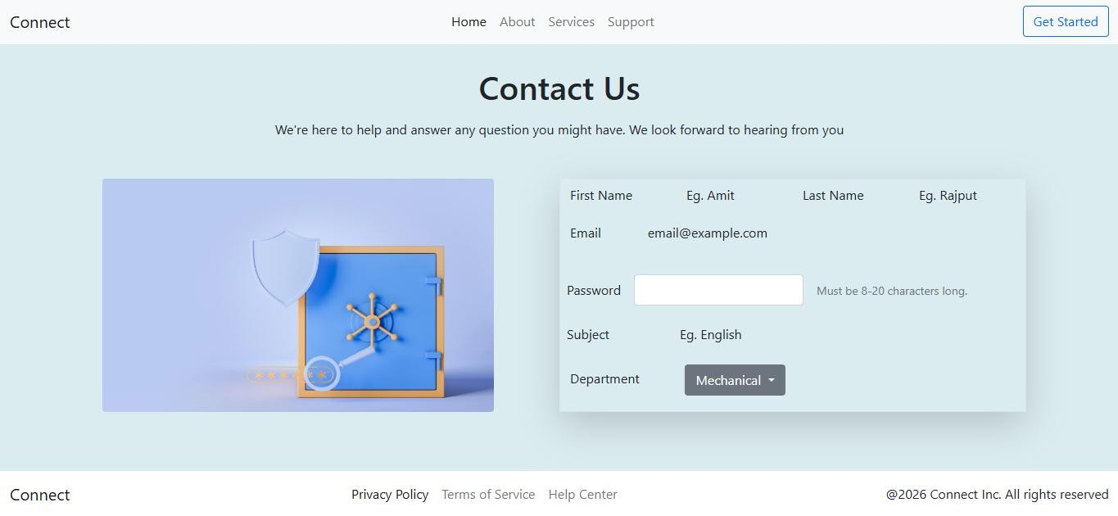

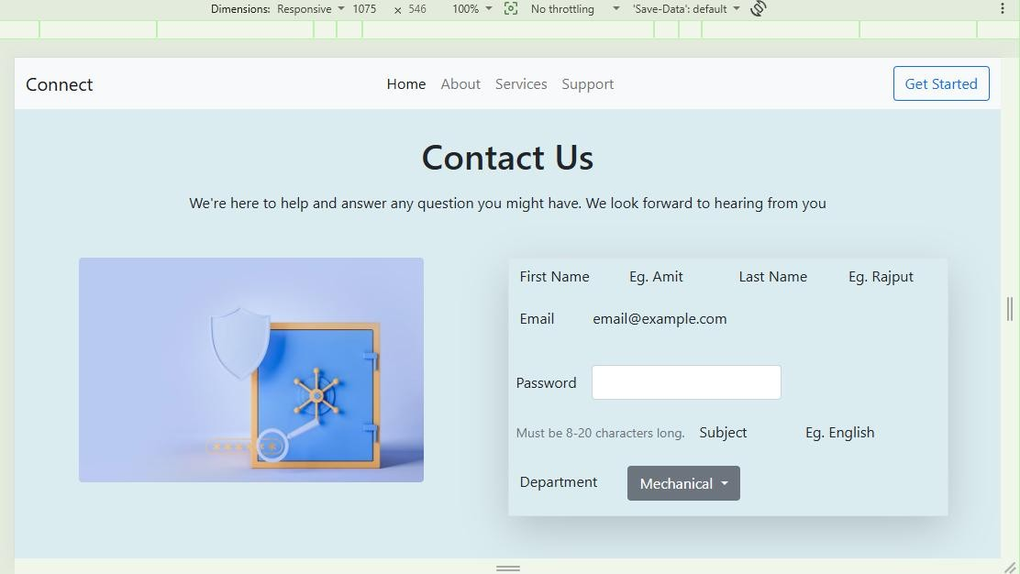

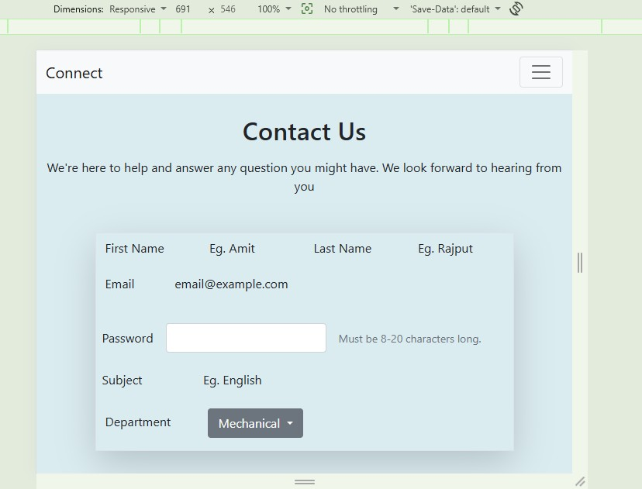
Logical Application
- Why does col-12 col-md-6 make fields stack on mobile but sit side-by-side on larger screens — what logic is Bootstrap applying here?

- If you removed the class="row" wrapper around the two col-md-6 divs, why would the layout break?

Practical 4
Aim: To perform CRUD operation.

Code
models/Item.js
const mongoose = require('mongoose');

const itemSchema = new mongoose.Schema({
name: {
type: String,
required: true,
trim: true
},
description: {
type: String,
default: ''
},
price: {
type: Number,
required: true,
min: 0
}
}, { timestamps: true });

module.exports = mongoose.model('Item', itemSchema);

server.js
const express = require('express');
const mongoose = require('mongoose');
const Item = require('./models/Item');

const app = express();
app.use(express.json());

// --- Connect to MongoDB ---
mongoose.connect('mongodb://127.0.0.1:27017/crud_demo')
.then(() => console.log('MongoDB connected'))
.catch(err => console.error('MongoDB connection error:', err));

// --- CREATE ---
app.post('/items', async (req, res) => {
try {
const item = new Item(req.body);
const savedItem = await item.save();
res.status(201).json(savedItem);
} catch (err) {
res.status(400).json({ error: err.message });
}
});

// --- READ ALL ---
app.get('/items', async (req, res) => {
try {
const items = await Item.find();
res.json(items);
} catch (err) {
res.status(500).json({ error: err.message });
}
});

// --- READ ONE ---
app.get('/items/:id', async (req, res) => {
try {
const item = await Item.findById(req.params.id);
if (!item) return res.status(404).json({ error: 'Item not found' });
res.json(item);
} catch (err) {
res.status(400).json({ error: 'Invalid ID' });
}
});

// --- UPDATE ---
app.put('/items/:id', async (req, res) => {
try {
const updatedItem = await Item.findByIdAndUpdate(
req.params.id,
req.body,
{ new: true, runValidators: true }
);
if (!updatedItem) return res.status(404).json({ error: 'Item not found' });
res.json(updatedItem);
} catch (err) {
res.status(400).json({ error: err.message });
}
});

// --- DELETE ---
app.delete('/items/:id', async (req, res) => {
try {
const deletedItem = await Item.findByIdAndDelete(req.params.id);
if (!deletedItem) return res.status(404).json({ error: 'Item not found' });
res.json({ message: 'Item deleted successfully' });
} catch (err) {
res.status(400).json({ error: 'Invalid ID' });
}
});

const PORT = 3000;
app.listen(PORT, () => console.log(`Server running on port ${PORT}`));
seed.js
Standalone script to insert a document directly via Mongoose, bypassing the Express API. Useful for seeding test data.
const mongoose = require('mongoose');
const Item = require('./models/Item');

mongoose.connect('mongodb://127.0.0.1:27017/crud_demo')
.then(async () => {
const item = await Item.create({
name: 'Laptop',
description: '16GB RAM, 512GB SSD',
price: 999
});
console.log('Inserted:', item);
mongoose.disconnect();
})
.catch(err => console.error('Error inserting item:', err));

Running the Project
npm install express mongoose
node server.js # start the API server
node seed.js # (optional) insert sample data directly

Logical Application
- What's the difference between findByIdAndUpdate() and save() when updating a document in Mongoose?

- Why do we use req.params.id instead of req.body.id to identify the resource in GET/PUT/DELETE routes?

